School mental health: Factors behind growing psychological problem in children in Nepal
April 13, 2017
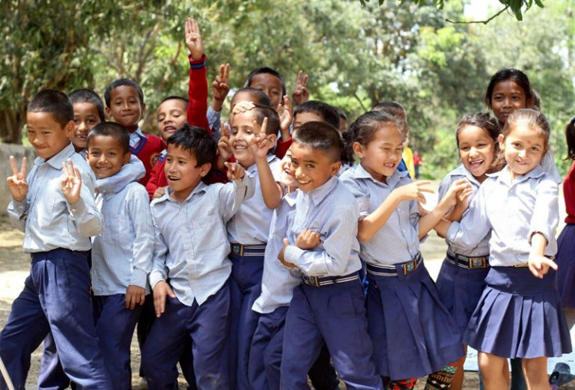
Trishna Ghosh Bista, April 13: Education system in Nepal has been imposing tremendous mental pressure on the children, not only momentarily, but it goes on molding the personality development of the child either in positive or negative manner.
I have come across many students during my five years tenure in mental hospital, who have fallen prey to the atrocities of the societal demand, who have lost their innocent smiles just to satisfy the innumerable pressure. Children come to mental hospital with varied problems in which school plays a pivotal role in creating them- including absenteeism, student drug abuse, and physical conflicts among students, lack of discipline, below average level of performance, school refusal, scholastic decline, teachers partiality, physical and verbal abuse from the teachers, and critical remarks from the parents due to their inability to meet the parental expectation.

We see children carrying the load of their school bag which is beyond their capacity. They are overburdened with homework/projects apart from their regular (9 am to 5 pm) school activity. This not only hinders their creativity but also burdens parents who at many times end up completing the assignments. Is it a valid way of judging the performance? Parents who are not educated struggle to help their wards. The cost of such home assignments are another factor affecting the mental health of the children. Not all children hail from rich homes; this further causes inferiority complex among children.
Schools allot 45 minutes session for each subject. Researchers have proved that an attention span of children who have not reached teenage is less than 15 minutes where as for adults it is 20-25 minutes (Dianne Dukette and David Cornish 2009). Again a question which arises is how effective are those sessions which is beyond the attention span of the children?
More so we also see parents/teacher blaming each other for the disruptive behavior being displayed by the ward. The educational system in our country is very much theoretical based with less emphasis in practicality. It directly or indirectly teaches the children to compete in an unhealthy manner. “It is not good to fail” -the very statement causes several psychological problems in children.
Not only the parents, teachers (school) is to be blamed? The concerned authorities dealing with the same are equally responsible for the psychological problems in children.
It is sad to state that in our country there is no provision or concession for children suffering from specific learning disability, deficit in intellectual functioning, no standardization of the fee structure being charged by different educational institutions.
My intention of writing is to bring to the notice of the concerned authorities the issues, so that they could jointly make an effort to eradicate the growing psychological problem in children generated by school.
(The author is an M.phil in Clinical Psychology)
http://nepalireporter.com/school-mental-health-children/#.WeRKFFmMlBk.email

